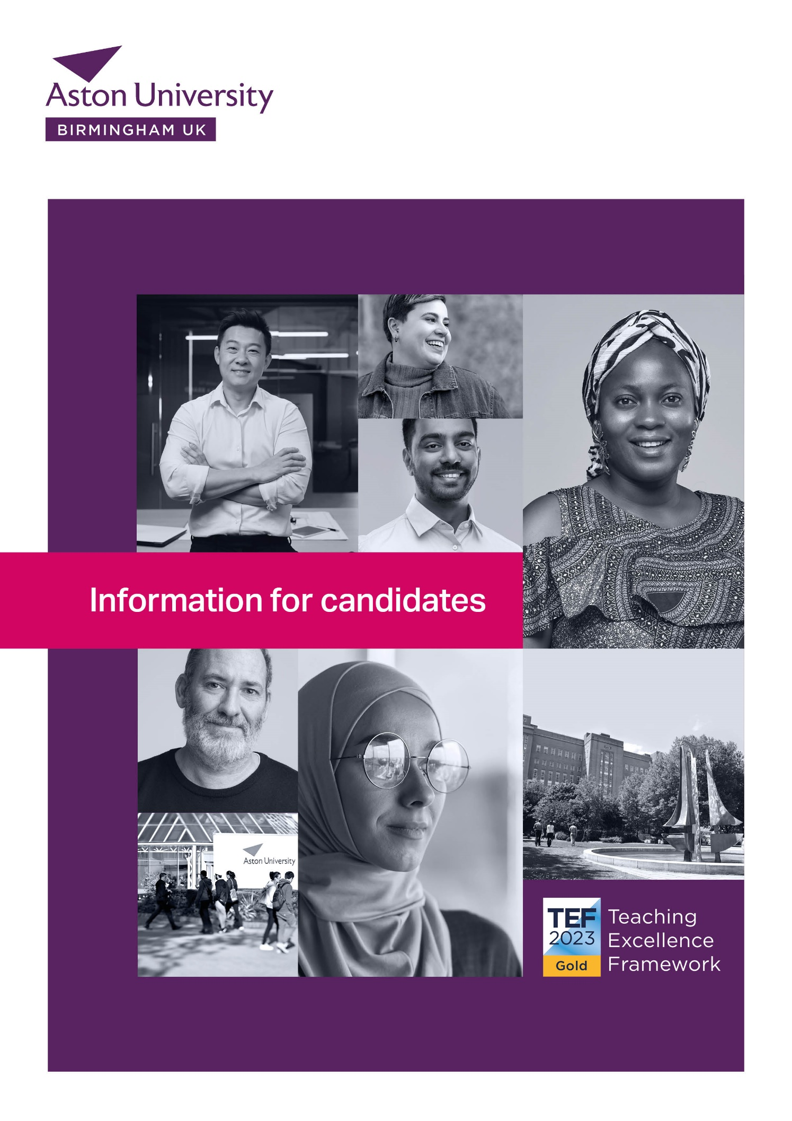

**Welcome from Professor Aleks Subic  
Vice-Chancellor & Chief Executive**

Dear applicant

Thank you for your interest in Aston University.

Aston University is a mid-sized dual intensive university ranked in the top 25 universities in the United Kingdom. We are an agile and innovative organisation that thrives on collaboration and partnerships with industry, businesses and the community. Our integrated placement year, our applied high-impact research, and our commitment to achieving best in sector employability and social mobility outcomes for our students, all help to make Aston University distinct both nationally and internationally.

We launched our new 2030 Strategy last year, an ambitious, game changing strategy focused on creating a new model of university for our changing world. We have defined Aston as a university that is inclusive, entrepreneurial and transformational, measured by the positive impact we create for our students and the communities we serve.

We are co-creating with our partners a world class innovation ecosystem here in the centre of Birmingham - the Birmingham Innovation Quarter and new UK Investment Zone, focusing on digital tech innovation, health tech and med tech, that will bring together the most creative minds, entrepreneurs and businesses, to drive socio-economic transformation and inclusive growth.

This is an exciting time at Aston!

In 2023 Aston University was awarded Triple Gold in the Teaching Excellence Framework (TEF), the only University in Birmingham to achieve this highest possible ranking. Aston was also named runner up University of the Year for Graduate Employment in The Times and Sunday Times University Guide 2024, the Daily Mail University of the Year for Student Success (2025) and ranked 21st in the UK in the Guardian University Guide, 2025

Our students rate their experience at Aston highly, with more than three quarters of respondents to the 2022 National Student Survey indicating their overall satisfaction, and more than 80% confirming high satisfaction levels for learning resources and staff support. We take great pride in our teaching quality and excellent student experience at Aston University.

Employability is embedded into everything we do at Aston University. We have an award-winning Careers and Placements team, who were named the Best University Placement Service in the UK at the 2022 National Undergraduate Employability Awards. Our staff are committed to doing all they can to meet the needs of students and to assisting them to achieve their career ambitions on graduation.

The most recent Research Excellence Framework (REF) assessments published in May 2022, ranked 79% of Aston University research as 'world leading' (4*) or 'internationally excellent' (3*). We are building on our world-class research capability to help transform industries, support economic growth and improve lives. Our research is organised within comprehensive interdisciplinary University Research Institutes and across a wide range of outstanding research centres and research groups.

We have much to offer our staff, students and partners at Aston and strive to make our university a friendly and inspiring place, that encourages and supports ambition, collaboration, inclusion, innovation and integrity.

We very much look forward to receiving your application to join Team Aston.

**Professor Aleks Subic**

**Vice-Chancellor & Chief Executive**



**Dear applicant,**

Thank you for your interest in Aston University. We are proud of our remarkable history as an anchor institution located in the Birmingham city centre. We have achieved some remarkable outcomes over the years - our most recent achievements include Aston’s **rapid rise in global and national rankings**, our status as the **highest-ranked university in Birmingham** (The Guardian University League Table), and being named the **Daily Mail University of the Year for Student Success 2024**. We are also the **only university in Birmingham** to achieve **Triple Gold** in the 2023 Teaching Excellence Framework (TEF), highlighting our exceptional commitment to excellent student outcomes, academic quality, and student support.

Building on our **2030 Strategy**, we have embraced an ambitious vision of Aston as an inclusive, entrepreneurial, and transformational university—measured by the impact we create for our students and communities. Our integrated placement year and applied high-impact research continue to distinguish us on both national and international stages, offering students immersive real-world learning experiences and opportunities to contribute to cutting-edge discoveries. We complement this with a steadfast focus on **employability** and **social mobility**, ensuring our graduates are best prepared to excel in diverse industries.

Aston’s leadership in **digital innovation** is central to our strategic direction. We have purposefully adopted AI across our research, teaching, and professional services, while collaborating with industry through the **Sir Peter Rigby Digital Futures Institute** and the **Aston–Capgemini Centre of Excellence for Enterprise AI**. Moreover, our presence in central Birmingham has been significantly strengthened by the acquisition of strategic infrastructure, including the historic **John Cadbury House and the Woodcock Street Building**, positioning us at the heart of business and enterprise.

Alongside our partners, we are co-creating the **Birmingham Innovation Precinct** and the **new West Midlands Investment Zone**, focusing on digital tech, health tech, and fin tech—bringing together entrepreneurs, businesses, and academics to drive inclusive growth and socio-economic transformation. All of this underscores our identity as a dynamic institution where ambition, collaboration, inclusion, innovation, and integrity thrive.

We warmly invite you to join **Team Aston** and help us shape the future of higher education, business, and community.

We look forward to receiving your application.



**About Aston University**

Founded in 1895 and a University since 1966, Aston is a long-established research-led university known for its world-class teaching quality and strong links to business and the professions. Aston University's enduring purpose has been to make our world a better place through education, research and innovation, by enabling our students to succeed in work and life, and by supporting our communities to thrive economically, socially and culturally.

The university was awarded Triple Gold in the Teaching Excellence Framework, 2023, due to Aston University's student experience and outcomes being typically outstanding.

Aston University has been placed in the top 25 of UK universities by The Guardian's annual league table. The rankings also place the University as 22nd in the UK for students' career prospects following graduation and we are ranked in the national top 25% for continuation rates and the value-added category, which assess support given to students towards achieving good grades. Furthermore, Aston University was named the Sunday Times University of the Year Runner-up for Graduate Employment, and we have made a significant improvement in QS world university rankings.

These rankings are a result of exceptional work and dedication of Aston University staff and their exceptional support of our students both during their studies and after they have graduated. The primary drivers of these rankings are an improvement in a number of areas, including teaching excellence, student satisfaction, employment outcomes and progression.

**Outstanding graduate employability**Ranked 18th for Graduate Prospects and named runner-up in the University of the Year for Graduate Employment Award (Times and Sunday Times University Guide, 2024), Aston University has been a leading university for graduate employment success. With placements integrated into our degree programmes, students develop essential work skills, build industry connections and a professional profile. We have strong relationships with national and international graduate employers, as well as smaller and local employers. These relationships are extremely important and make a real contribution to graduate employability.

**Career focused programmes**Close and established links with business, the public sector and the professions ensure that our career focused degree programmes are inspiring, challenging, and constantly updated to equip students with essential work-related skills and experiences.

**Excellence in teaching and research**Shortlisted for Business School of the Year in the THE Awards 2023, we are committed to high quality teaching and academic excellence, ensuring we provide the highest standard of education to our students. Aston University has an excellent reputation for research which shapes and improves lives. We're proud of the quality of our research and the real-world applications developed as a result - it makes a substantial and beneficial difference to people, organisations and society.

The 2021 Research Excellence Framework (REF) assessments, undertaken every seven years, were published in May 2022. Aston University took an inclusive approach to its REF return, with a 100% submission of eligible staff across seven REF assessment units and more than doubling its 'research power' since REF 2014. REF 2021 rated 79% of Aston University research as 'world leading' (4*) or 'internationally excellent' (3*).

**International**Placed in the Global Top 30% (QS rankings 2024), Aston University is a popular choice for international students. We recognise and welcome the important academic contribution and cultural diversity international students bring to our university environment. Students from over 120 countries study at Aston University choose to study at Aston University each year.

**Birmingham - one of Europe's liveliest cities**

Birmingham has a rich history which makes the city a unique and inspiring place to visit. It is recognised as a leader in leisure, entertainment, shopping and sport and is an international centre for business, commerce and industry. Birmingham is home to world-class companies, innovative entrepreneurs and has one of the youngest populations in Europe. It is a dynamic, business-focused region that is well connected and centrally located in the UK.

**A green, sustainable campus**

Located in the centre of Birmingham our green, 40 acre campus houses all the University's academic, social and accommodation facilities for our students. All staff have the opportunity to contribute to our sustainability agenda and practices. The university is ranked in the Top 30 for ethical and environmental performance by People & Planet (2022)

**Academic colleges and schools  
  
College of Business and Social Sciences (BSS)**-Aston Business School-School of Law and Social Sciences

**College of Engineering and Physical Sciences (EPS)**

- School of Engineering and Innovation

- School of Infrastructure and Built Environment

- School of Computer Science and Digital Technologies

**College of Health and Life Sciences (HLS)**

- Aston Medical School

- Aston Pharmacy School

- School of Biosciences

- School of Optometry

- School of Psychology

**Our beneficiary groups**

The University's beneficiaries are identified as three groups:

**Students**The first and primary beneficiary of Aston University are the individuals who form our student body and who progress to become our alumni. Aston University places students at the heart of our academic and professional endeavour. Through our industry placements, students are at the coalface of our interaction with industry.

**Business and Industry**  
Our strategy has an emphasis on the businesses and other external organisations who engage with us. Aston University is a market leader in industry-engaged research, as well as graduate employability. Our industry partners benefit from our work through our leading research and knowledge exchange, and from the quality of graduates we produce. Each student at Aston University is offered the opportunity for a year-long work placement; these placements not only cement our relationships with industry but ensure businesses have access to work-ready graduates.

**Region and Society**  
We are committed to having a positive and transformative impact on Birmingham and the West Midlands. Birmingham is one of the youngest cities in Europe and Aston University plays an important civic role by educating the leaders of the future. By emphasising research that has a regional impact, engaging with local businesses to develop a strong economy and educating top graduates, we are helping to shape our society around us.

**Our vision, purpose and values**

**Our vision** is to be a leading university of science, technology and enterprise, measured by the positive transformational impact we achieve for our people, students, businesses and the communities we serve.

**Our purpose** is to make our world a better place through education, research and innovation, by enabling our students to succeed in work and life, and by supporting our communities to thrive economically, socially and culturally.

**Our values:  
  
AMBITION**: Our ambition drives us to advance and accomplish our goals, strive for excellence and impact, and create value for our beneficiaries and communities.

**COLLABORATION:** We believe in the value of working together for a shared purpose, by engaging and collaborating across our teams and disciplines, as well as with our beneficiaries.

**INCLUSION:** We provide an inclusive, caring and empowering environment for all and respect and support the values that diversity and inclusion bring to our whole community.

**INNOVATION:** We nurture an innovative environment that values new ideas, seeks diverse perspectives and pursue game-changing innovations that make a positive impact.

**INTEGRITY:** By valuing honesty, trust, fairness and ethical behaviour we always act with integrity and hold ourselves and others accountable.

**An inclusive university**Inclusion and diversity are essential values and go right to the heart of who we are as a university. Each and every one of us at Aston University is unique with different backgrounds and cultures, different experiences, skills and ideas. Our central location in Birmingham is a welcoming, diverse and inclusive city.

**An entrepreneurial university**We've made significant strides in almost every field driven in particular by science, technology and digital transformation. Creating the Birmingham Innovation Quarter (B-IQ) with our partners Bruntwood SciTech, Birmingham City Council and others, redefines Aston University as an enterprising university. We are co­ creating an innovation ecosystem of global significance to enable innovation at scale and pace, to attract enterprising talent, and create enterprising graduates, our future leaders of innovation and change.

**A transformational university**Being transformational means embedding professional practice in all our courses to drive employability and social mobility; encouraging interdisciplinary teaching and challenge based research; developing entrepreneurs internally and externally to drive innovation and inclusive growth; facilitating a collaborative co-creation approach with industry and business focused on value realisation, embedding industry teams and professionals within the university environment; fostering lifelong connectivity with our students and expanding our international collaborations.

**University values**All staff are expected to demonstrate/promote the University's values and expectations, which are an integral part of our strategy and underpin the culture of the University. In addition, our leaders are expected to be accountable, help to execute strategic visions of the University and share and set clear expectations that inspire those around them.

**Our commitment to you**

Our Commitment to You weaves through everything we do at Aston University. This provides a consistent approach and a common language across the university when interacting with others, and is shared internally and externally so people can see our pledge and know what to expect when they interact with us.

The commitment includes four statements of intent that outline the beneficiary and customer experience we strive to deliver:

**Listening to you**

We listen to you and take action to deliver the best experience by:

* Actively listening when in conversation.
* Asking for your feedback to understand how to improve your service experience.
* Responding to your feedback by sharing expectations of if and when we can meet your needs. Putting ourselves in your shoes and seeing the situation from your perspective.
* Acting in your best interests by putting you at the heart of what we do.

**Meeting your needs**

We keep things simple in order to deliver the right outcomes for you by:

* Explaining information clearly.
* Getting the basics right, from your first interaction with us through to your last and beyond.
* Keeping you informed along the way and doing what we say we will do.
* Challenging our policies and processes, and exploring innovative ways to improve the service we provide to you.

**Taking responsibility**

We take responsibility for our actions and manage your expectations by:

* Working with our colleagues across the University to find the best outcome for you first time round.
* Using our initiative when problems arise, making appropriate decisions and providing the right solutions for you.
* Apologising sincerely when we are wrong.
* Being honest and inclusive, treating you fairly and with respect.
* Challenging ourselves so we can continue to deliver on our promises.

**Easy and welcoming**

We make it easy and engaging when you interact with us by:

* Making you feel welcome and getting to know you.
* Showing genuine interest in you and being fully engaged as we interact.
* Empathising and acknowledging challenges you may be facing, making it easy for you to interact with us by removing barriers that are in the way of meeting your service needs.
* Always being professional with you and creating a positive lasting impression so you look forward to interacting with us.

**Benefits and rewards**

We focus time, energy and resources on making this a great place to work. To recognise the contribution of our outstanding people, we have developed a comprehensive reward and benefits package for you.

At Aston University, the future's always front and centre. The work we do here is positively affecting lives across the UK and beyond. And it's why we focus time, energy and resources on making this a great place to work. Because we recognise that none of this can be done without our outstanding people, across all areas of our organisation.

The size and scope of the university means that the opportunities on offer are as diverse as the people who work here. From a generous annual leave scheme, gym membership, on-site nursery and flexible working to opportunities to volunteer in the community, there is something for everyone.

To find out more, visit:   
[www.aston.ac.uk/staff-public/hr/Benefits-and-Rewards](http://www.aston.ac.uk/staff-public/hr/Benefits-and-Rewards)

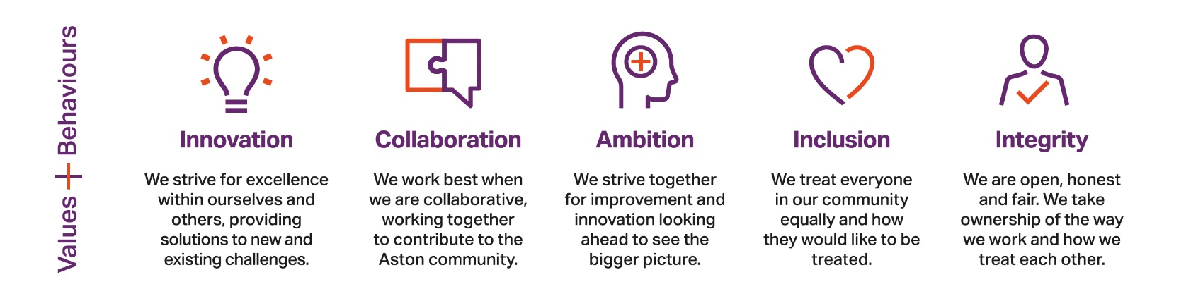

Diagram showing our behaviours, values, purpose, vision and our commitment to you. 

Our commitment to you (customer framework) 
Listening to you
Meeting your needs
Easy and welcoming
Taking responsibility

Behaviours: 
Make it happen
Focus on impact
Think big picture
Serve our beneficiaries
Be your best self

Values:
Innovation
Ambition
Collaboration
Inclusion
Integrity
**A picture of Zoe Radnor, Pro-Vice chancellor and Executive Dean of College of Business and Social Sciences. 

Text says: College of Business and Social Sciences. Welcome from Professor Zoe Radnor. Pro-Vice Chancellor and Executive Dean College of Business and Social Sciences. **

**The College of Business and Social Sciences comprises two Schools: Aston Business School and the** **School of Law and Social Sciences**

The Schools are coming together as a unified entity to realise the benefits of the new College building a great culture based on shared values and experiences, innovation and collaboration.  
 **College organisation**

The College of Business and Social Sciences is led by a Pro-Vice-Chancellor and Executive Dean with a senior management team led by the Deputy Dean consisting of Associate Deans, a Head of School and Department Heads for each of our subject disciplines.

The Schools are supported in their work by advisory boards, whose membership is drawn from alumni and key stakeholders from the City of Birmingham and beyond.

**Aston Business School**

Aston Business School is part of an elite group of global business schools who hold the gold standard of 'triple-crown' accreditation from AACSB (Association to Advance Collegiate Schools of Business), AMBA (Association of MBAs) and EQUIS (European Quality Improvement System).

We are also in the top 100 in the world for Business and Management studies (QS World University Rankings 2020).

Aston Business School has the University's highest international QS ranking, highest levels of student satisfaction, ongoing educational innovation, as well as high profile research activity through its research centres.

**Our Vision** -Aston Business School will be a global leader in bridging the world of intellectual discovery and the practical needs of enterprises and the professions.

**Our Mission** - Our goal is to enhance enterprise and enterprises. We develop individuals to perform better within enterprises and the professions, and to create successful new ventures.

We support business leaders in enhancing their organisation's performance and growth. We advise policy­ makers on ways to improve society and the economy. Our research creates new knowledge that furthers these aspirations. It is our particular aim to ensure that the opportunities we create are made available to all members of our society.

**School of Law and Social Sciences**School of Law and Social Sciences has an established record of excellence in legal education, based on an ethos of strong student support. We are proud of the diversity of our student population and the quality of our teaching, which is reflected in our high student satisfaction scores. We support students to develop their personal approach and skills, boosting their employability and future career potential.

We prepare students for a diverse range of careers in law and other industries. From intellectual property to corporate governance and commercial law, students have a wide range of options at their fingertips from day one.

Our staff are regarded as leaders of legal education, evidenced through national teaching awards, recognition at the highest level by the Higher Education Authority and by the award of National Teaching Fellowships. Many of Aston Law School's academics are qualified lawyers and are passionate about their subjects.

Our research is top quality and looks not only to the law as it is, but as it might be in the future. Our research into property in its widest sense is changing the law internationally: researchers from Aston advise governments and the international law community, while our work in 'New Commerce' explores the role and development of law in critically important areas such as FinTech, Techlaw, Internet law, International Business and Digital Justice. These are areas that already affect the legal profession, and our research informs and impacts the ways in which they are regulated.

Making a difference to society is at the heart of everything we do at the School of Social Sciences and Humanities. It's what helps us create a better world and is also how we embrace diversity to grow understanding and build opportunities.

We strive to offer our students a quality education that supports their graduate outcomes and their future choices. We operate at the heart of a dynamic, diverse and global city, offering our expertise to businesses and professions by shaping our placement students and graduates, and by working in partnership with organisations and authorities. In addition, our research is applied, impactful and recognised as excellent - both in national and international contexts.

The new structure allows for a more collaborative approach to teaching and learning across Aston Business School and the School of Law and Social Sciences. Current programmes already demonstrate the benefit of offering more integrated programmes from disciplines across the new College.

**Research in the College**

The contribution research can make goes beyond health and medical research into areas of expertise within the College - the economic impact, public policy and supply chain management. There is huge potential for collaboration across both the College and the University to find solutions to these problems.

There are excellent and established research centres within the College: the Aston Centre for Europe, the Advanced Services Group, the Aston Centre for Growth, the Centre for Research in Ethnic Minority Entrepreneurship (CREME), the Centre for Language Research at Aston and the Lloyds Banking Group Centre for Business Prosperity to name a few.

In June 2019, £5.5 million was awarded by Research England to establish the Aston Institute for Forensic Linguistics, led by Prof Tim Grant. It is the first institute of its kind in the world, combining leading-edge research and investigative practice with teaching and training in forensic linguistics, and is one of Aston's four flagship University Research Institutes (URls).

We are also blending our research excellence across disciplines. Across the School of Social Sciences and Humanities and Aston Law School, the new Centre for Language and Law will be led by Professor Lauren Devine who brings with her, £800k of research funding.

Research at Aston Business School (ABS) focuses on delivering excellence, innovation and impact. Our departments and research centres work together to further our understanding of key business disciplines and issues. In the latest Research Excellence Framework, 100% of our research achieved 3* or 4*.

Examples of our research in practice include:

* Internationally leading research on growth, innovation and productivity of small and medium-sized/enterprises (SMEs) through our joint Enterprise Research Centre (ERC) with Warwick Business School.
* Unparalleled expertise in SME engagement through the work of the Aston Centre for Growth (ACG), which offers growth programmes and other opportunities for SME owners such as the Goldman Sachs 10,000 Small Businesses and BSEEN, a start-up support programme funded by the European Regional Development Fund.
* The Advanced Services Group (ASG) specialises in the organizational transformation of manufacturing companies to compete through advanced services and has worked with over 180 companies such as Baxi, Nederman and Thales, as well as many SMEs.
* Since 2018 ABS hosts the Centre for Research in Ethnic Minority Entrepreneurship (CREME) which has transformed the perceptions of ethnic minority entrepreneurs by working with business policy­ makers and influential organisations to engage collaboratively with overlooked business communities.
* Through the Lloyds Banking Group Centre for Business Prosperity (LBGCBP), we help Britain prosper by promoting a better understanding of what affects UK economic performance by conducting rigorous research in the areas of productivity, trade, skills, regional economic growth, and international trade and investment.

**Teaching**

We pride ourselves on our teaching, which has been awarded Gold in the Teaching Excellence Framework - the highest possible accolade and the benchmark used by government.

Our staff have established a reputation for developing innovative teaching methods to make our students' learning experience more rewarding, including pioneering the use of gamification.

Our students experience real-life business activities through placements and initiatives including a module partnership, in-house business and law clinics, and collaboration with charities such as The Prince's Trust. Moreover, our Small Business Charter accreditation recognises the support we offer to SMEs.

We also do more to boost the earnings of our graduates than nearly every other university in the UK, according to a new study by The Economist. The average salary for Aston business graduates is 39% higher than the sector average (five years after graduation). (Longitudinal Educational Outcomes 2020).

Two of Aston's core values are that we are innovative and collaborative. These values have been evident across the College over the last couple of months and are an important basis for our emerging culture. As we go forward and embrace these values as we have done in recent weeks, we will have a strong foundation on which to build for the future.

In addition to the Guardian award of University of the Year 2020, it also awarded us the Times Higher Education Outstanding Entrepreneurial University of the Year and the 'Buildings that Inspire' Award for our new students' union building. Aston University has also been recognised as the 'Best University Careers/ Employability Service' at the National Undergraduate Employability (NUE) Awards 2020.

